**Homework Problems:**

**1.5.1 Handwritten Digit Denoising**

This work demonstrates how we can use the kernel methods for denoising the handwritten digits with varying details of different parameters. Usually, a rule of thumb for σ2 is calculated as the mean of the variances of each dimension times the dimension (number of features) of the training data. The σ2 hyper-parameter plays a major role in the performance of the denoising, and should be tuned for meeting the desired performances. When we change the value of σ2 to a much bigger value compared to the previous rule of thumb with increase in the noise factor , we obtain various results which all are presented below. We also observe that if the value if the value of σ2 is too high, denoising with kernel PCA deteriorates. As noise is associated with darker colors, higher values of σ2 imply that each point will be influenced by more adjacent points in the denoising process. Therefore, higher values of σ2 lead to a less efficient denoising algorithm which can be seen below.

Sigma2=0.7

noisefactor=0.3

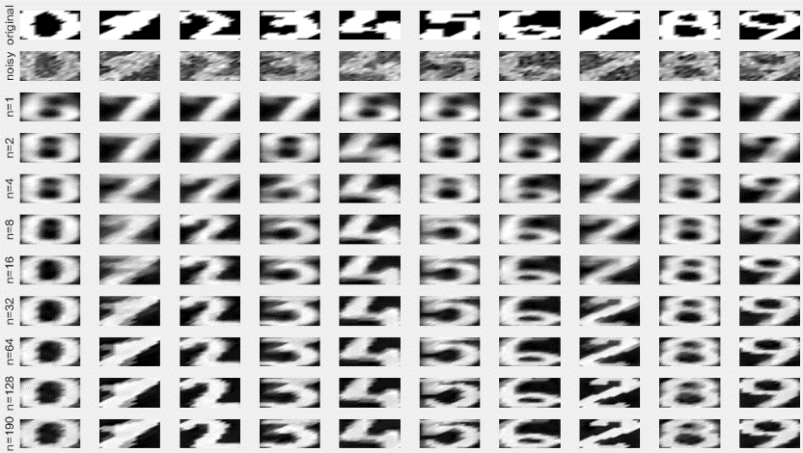

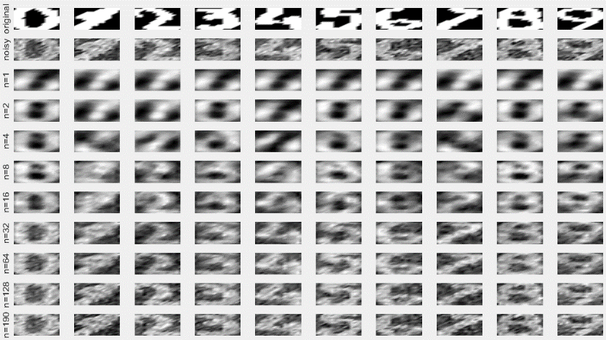

Sigma2=0.01

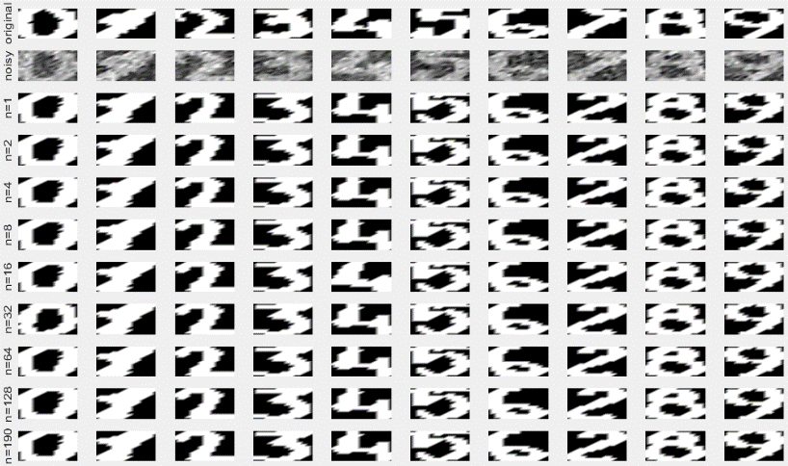noisefactor=0.3

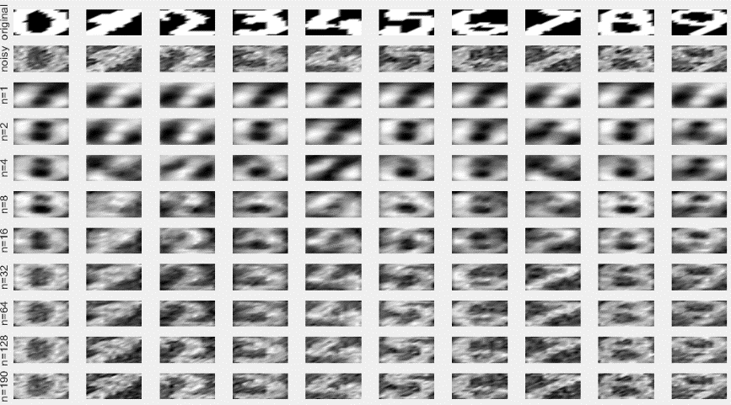

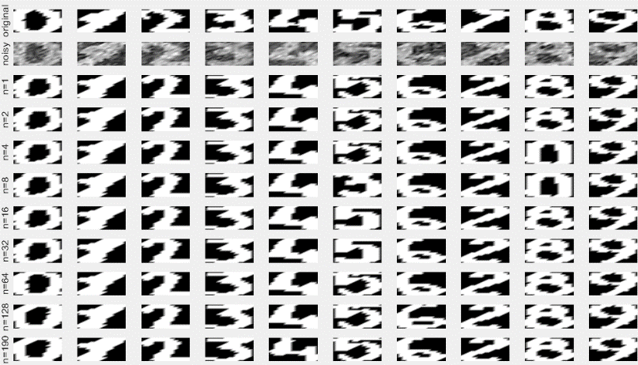

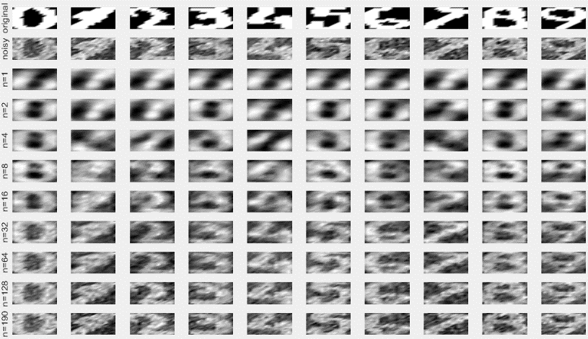Sigma2=0.1

noisefactor=0.3

Sigma2=1

noisefactor=0.3

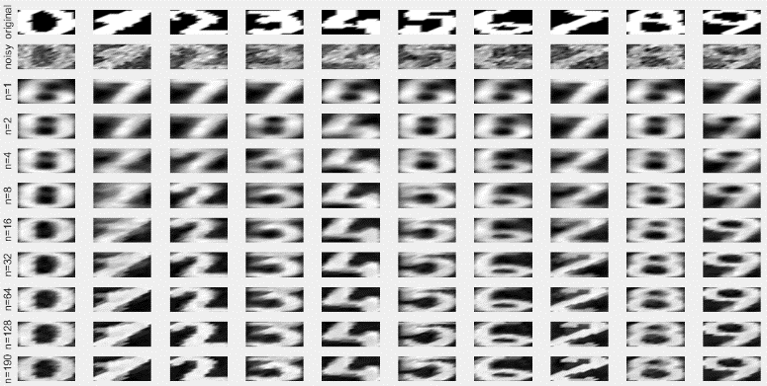

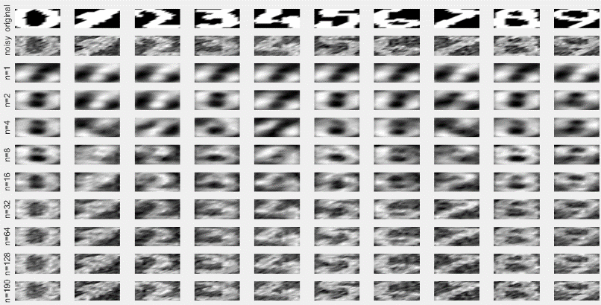

Sigma2=0.7

noisefactor=0.4

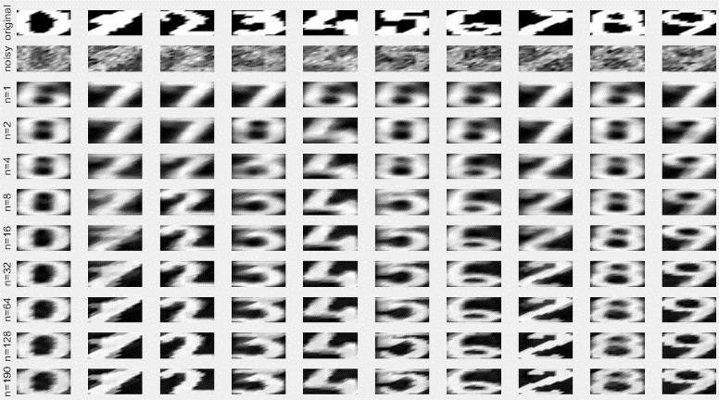

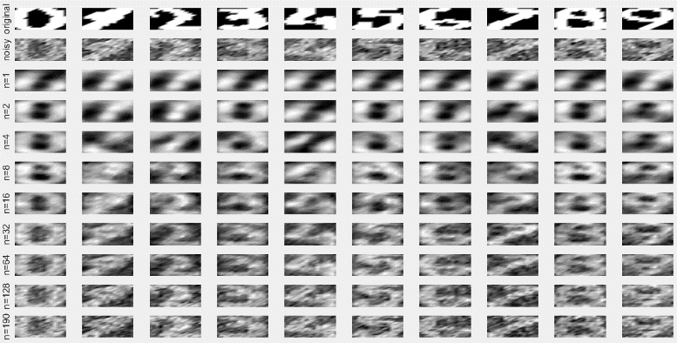

Sigma2=0.7

noisefactor=0.5

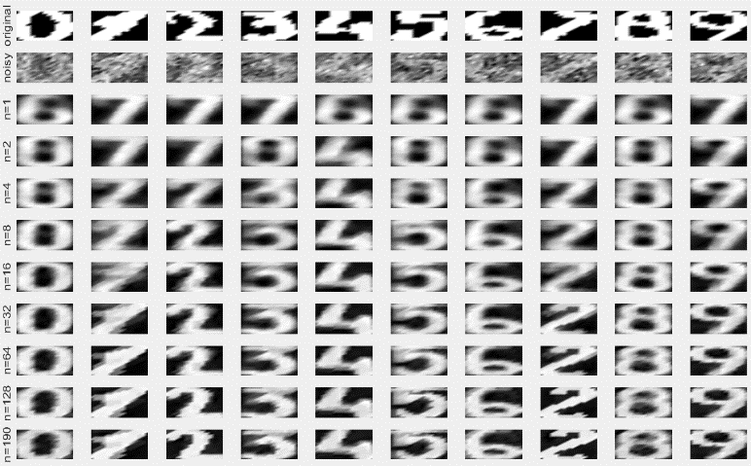

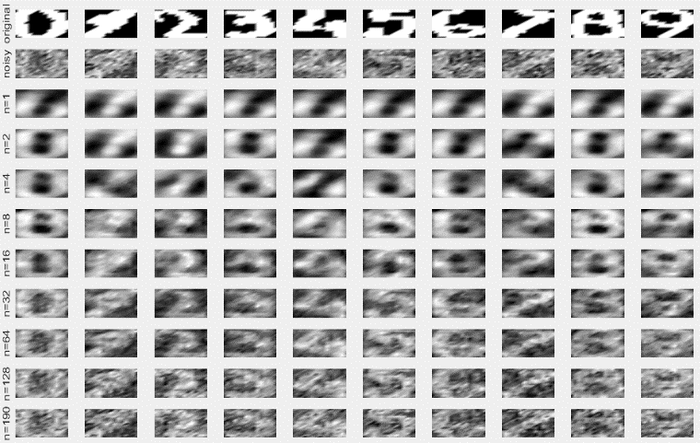

Sigma2=0.7

noisefactor=0.7

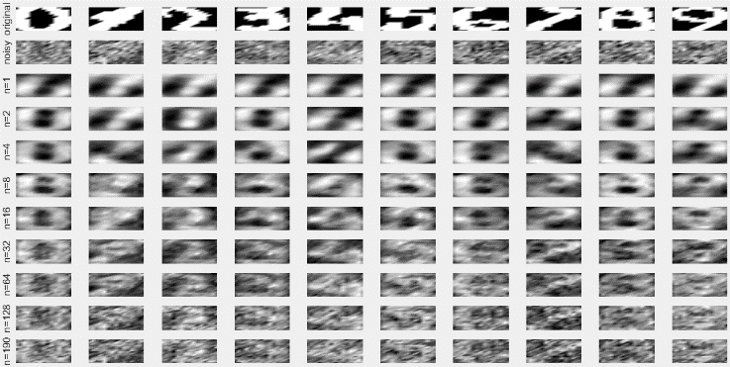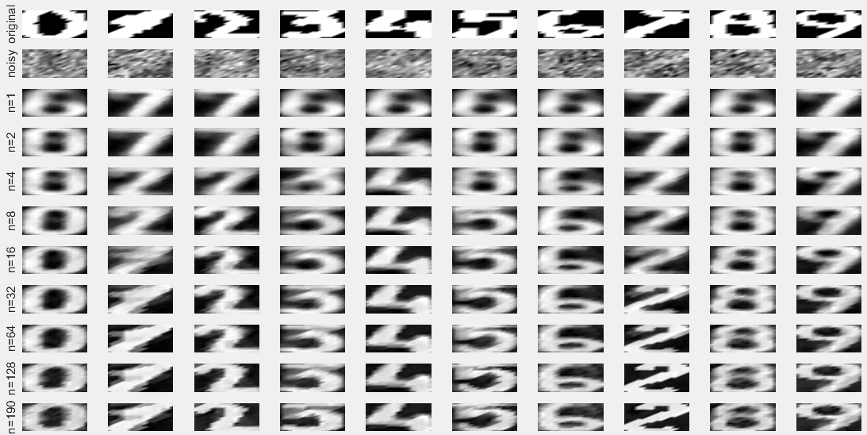

Sigma2=0.7

noisefactor=0.9

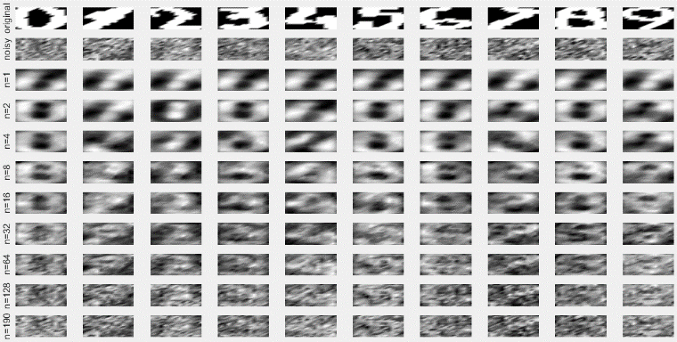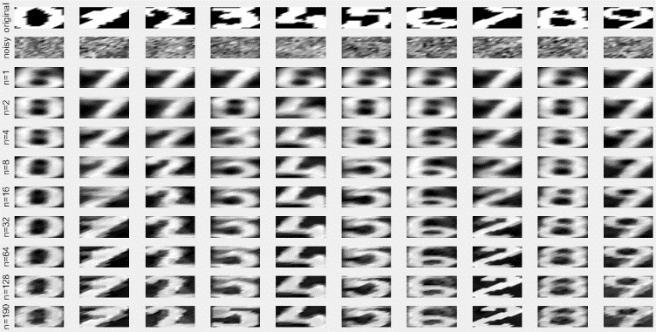



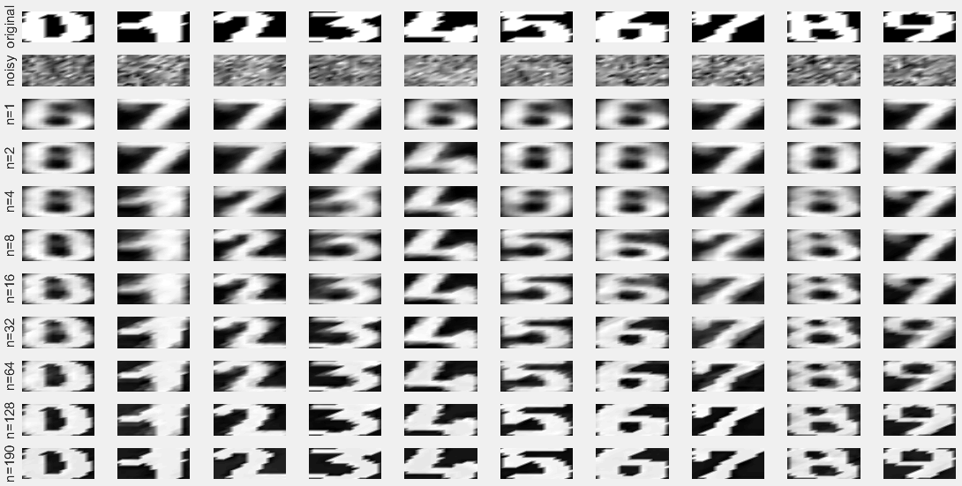

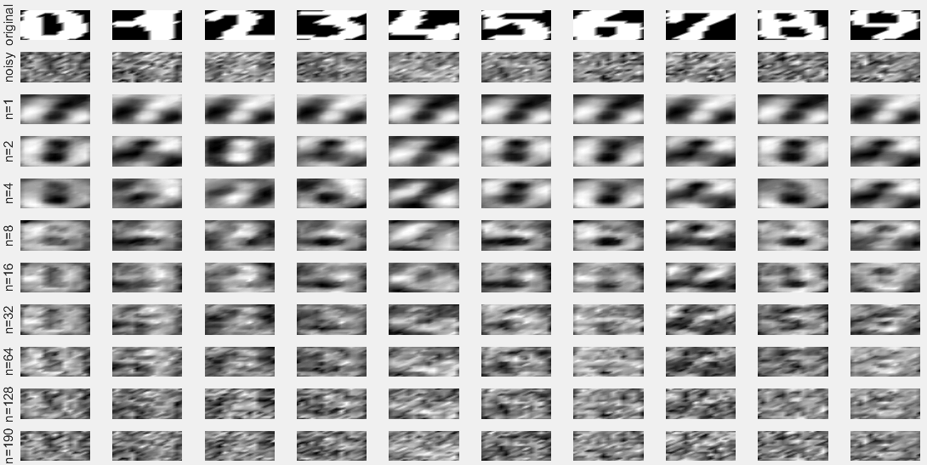

We chose σ *factor* that minimized the reconstruction error on the validation set (Xtest1). The exact value minimizing reconstruction error depends on the number of principal components we keep for the denoising. However, we can observe from these Figures that the reconstruction error is always minimized around a σ *factor* value of 0.5. Therefore, we use this same σ *factor* on the test set(Xtest2).We observe that again, kernel PCA (left) gives much better results than linear PCA.